# Overview

This document contains the necessary information to use the Chatterbox. The Chatterbox is a switch scanning communication device which provides auditory feedback to guide the user while scanning.

Contents

Overview 1

Introduction 3

Features 3

Specifications 7

Compatibility 7

Usage 7

Powering the Chatterbox 7

Initial Setup 7

Regular Use 8

Takedown / Storage 11

Switch cap customization 11

Cleaning 12

Care 12

Disposal 12

## Introduction

The Chatterbox is an Augmented and Alternative Communication (AAC) device that allows users to play pre-recorded messages using single or dual switch scanning. The Chatterbox provides auditory and visual feedback to indicate the message a user can play. The Chatterbox is meant for users with complex communication needs and visual impairment.

## Features

The following pictures show the different features of the Chatterbox. The features and their functions are described in the table following the images.

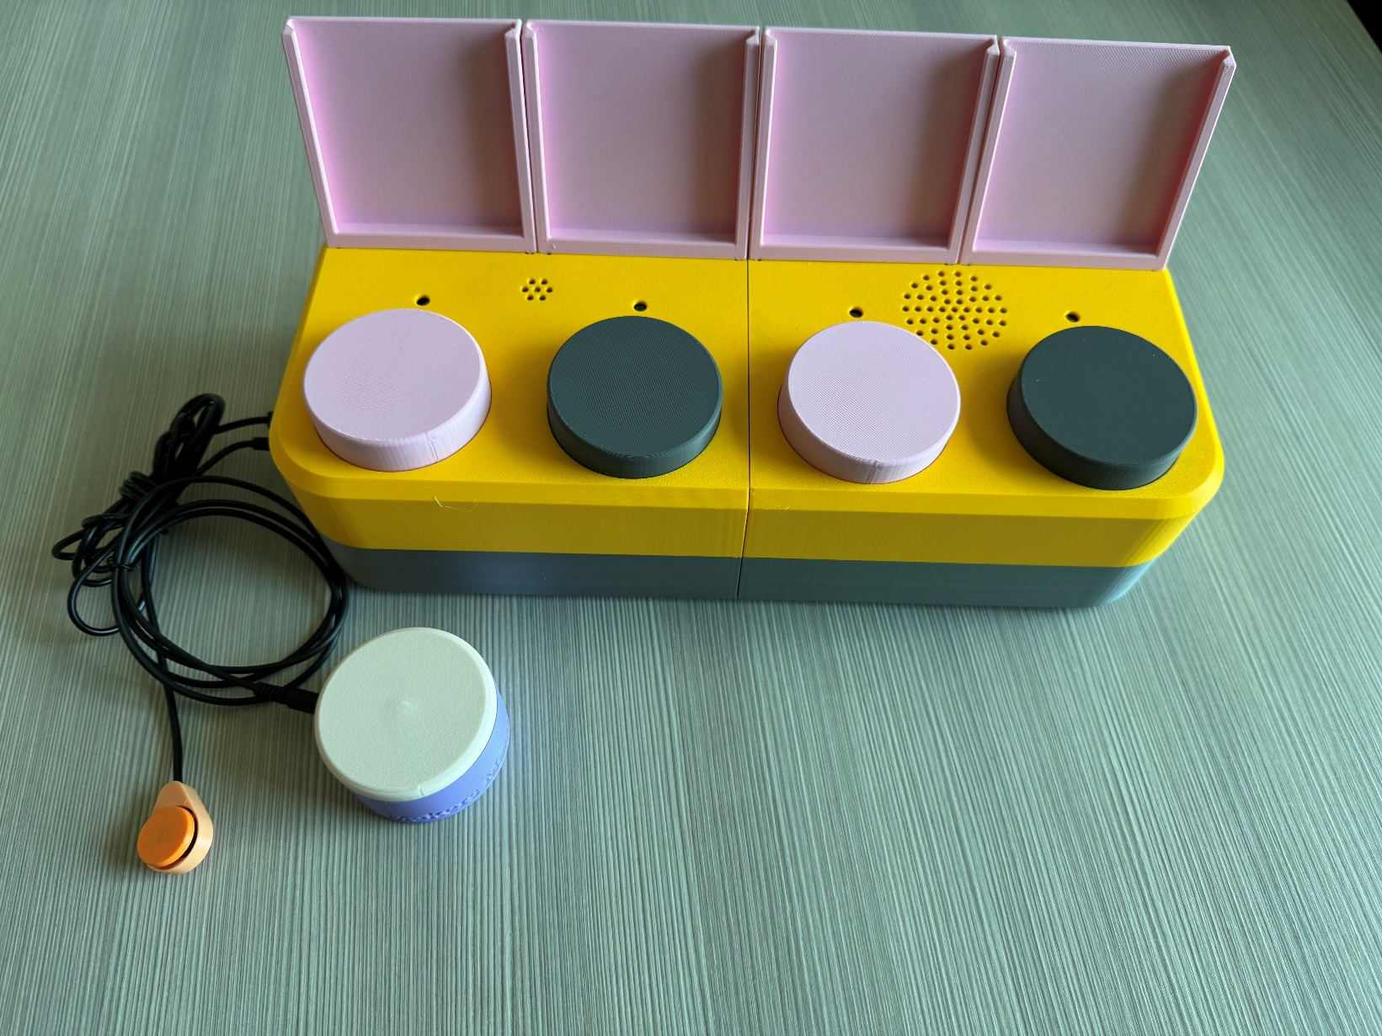

Assistive Switches for switch scanning (not included with device unless requested)

Direct access switches

Speaker

Mic

Message LEDS

Label holders

|  |  |
| --- | --- |
| Feature | Function |
| Label holders | Hold customized labels above each switch to represent the message recorded at that switch. |
| Message LEDs | * Indicate which message is playing/will be selected while switch scanning (when lit) * Indicate if the device is in Record Mode (when all four are flashing) * Indicate which message is being recorded (when flashing) |
| Speaker | Holes above the speaker to allow sound to escape the enclosure more easily. |
| Mic (microphone) | Holes above the microphone which is used when recording new messages. |
| Direct Access Switches | * Play a specific message without switch scanning (when pressed in Playback or Record Mode) * Record a message (while held in Recording Mode) |
| Assistive Switches for switch scanning | * Start switch scanning (SEL switch) * Select the message to play back (SEL switch) * Advance to the next message (NXT switch)   Note: The switches pictured are for demonstration purposes. They are not included with the Chatterbox and can be any switch that uses a 3.5mm mono cable. |

|  |  |
| --- | --- |
| Feature | Function |
| SELECT assistive switch port | * Start switch scanning * Select current message to play back   This port must be used for single or dual switch scanning. |
| NEXT assistive switch port | * Advance to the next message   This port is required only if the user wants to use dual switch scanning. |
| USB Port | * Access to microcontroller’s USB-C port for reprogramming. * Power device from USB (if desired) |
| Mode Switch | Change between Playback and Recording modes. |

|  |  |
| --- | --- |
| Feature | Function |
| Power Switch | * Turn the Chatterbox on or off. * Not required if powering the device with USB. |
| Level Switch | Change between message levels (three positions and three levels). |
| Volume knob | Adjust the volume of message playback. |
| Speed Switch | Change between different pre-set delay times between messages while switch scanning. (Three positions and three speeds). The pre-set delays are 3, 5, and 7 seconds. These can be changed in the Chatterbox firmware. |

|  |  |
| --- | --- |
| Feature | Function |
| Battery holder (on the bottom of the device) | * Holds the battery inside the Chatterbox * Prevents accidental access to the battery |

Swappable switch cap

Switch base

|  |  |
| --- | --- |
| Feature | Function |
| Swappable switch cap | * Screw-on switch cap that can be changed to customize the top of each direct access switch |
| Switch base | * Threaded base that holds different screw-on switch caps. |

## Specifications

|  |  |
| --- | --- |
| Item | Chatterbox |
| Size (Length x Width x Height) [mm] | 330 x 140 x 80 (main enclosure body only) 330 x 156 x 150 (including label holders and volume knob) |
| Mass [g] | 884 |
| Visible area of label (Length x Width) [mm] | 70.6 x 70.2 |
| Maximum label dimensions (Length x Width x Thickness) [mm] | 71.6 x 71.2 x 1.5 |

## Compatibility

The Chatterbox uses two 3.5mm mono jacks to connect up to two assistive switches to operate the switch scanning function. Any assistive switch with a 3.5mm mono cable can be used with the Chatterbox.

## Usage

### Powering the Chatterbox

The Chatterbox runs on a 9V battery. If the device does not turn on or is not functioning properly, check the battery is connected properly. You can access the battery through the battery holder on the bottom of the device. You will need a Phillips head (+ shaped) screwdriver to remove the screw that keeps the holder shut.

You can also run the Chatterbox through the USB port on the side. This can be plugged into a computer/laptop, a wall adapter, or a USB battery bank. **DO NOT USE BOTH THE 9V BATTERY AND USB PORT AT THE SAME TIME TO POWER THE CHATTERBOX.** Remove the 9V battery, or make sure the power switch is set to “OFF” before plugging into USB power.

### Initial Setup

Messages need to be recorded on the Chatterbox before it can be used for switch scanning communication. The process to record messages is outlined in the next section. Once the messages are recorded, the Chatterbox should be placed in front of the user facing them, as seen below. The Chatterbox should be positioned so the user can see the message LEDs above each direct access switch, in case they have partial sight.

The Chatterbox can be used on a user’s wheelchair tray, on a desk/table, or any other flat surface that is large enough to hold it. If the user is moving around with the Chatterbox, or is expected to be pushing on it during use, you may want to place it on a non-slip surface, such as a Dycem mat.

The Chatterbox can be used with any assistive switch that has a 3.5mm mono cable connection, and these switches can be plugged into the ports at the side of the device. The switches should be chosen to suit the user’s needs, and mounted appropriately for their abilities.

### Regular Use

#### Recording new messages

1. Turn on the Chatterbox.
   1. If using the 9V battery: slide the POWER switch to the ON position
   2. If powering through the USB: plug the Chatterbox into a power source (laptop/computer, USB charger, power bank, etc.) with a USB-C cable.
2. Use the MODE switch to change to Recording Mode (if the device is not already in Recording Mode). Recording Mode is indicated by all four message LEDs flashing.
3. Use the LEVEL switch to adjust to the message level you would like to change.
4. Hold down the direct access switch for the message you would like to record. When only the corresponding message LED is flashing the device has started recording.
5. While holding down the direct access switch, speak or play audio clearly into the mic holes.
6. Once the message is recorded, release the direct access switch. All four message LEDS should start flashing.

You can play a recorded message at any time in Recording Mode by pressing a direct access switch. This can be useful to listen to test a message playback before changing modes, or to identify the messages already recorded on the device.

#### Playing messages with direct access switches

1. Turn the Chatterbox on.
   1. If using the 9V battery: slide the POWER switch to the ON position
   2. If powering through the USB: plug the Chatterbox into a power source (laptop/computer, USB charger, power bank, etc.) with a USB-C cable.
2. Regardless of mode, press the direct access switch for the message you would like to play.

#### Single switch scanning

1. Plug an assistive switch into the SELECT assistive switch port.
2. Turn the Chatterbox on.
   1. If using the 9V battery: slide the POWER switch to the ON position
   2. If powering through the USB: plug the Chatterbox into a power source (laptop/computer, USB charger, power bank, etc.) with a USB-C cable.
3. Use the MODE switch to change to Playback Mode (if the device is not already in Playback Mode). All message LEDS will be off unless a message is being played, or switch scanning has started in Playback Mode.
4. Use the LEVEL switch to select the message level you would like to play back.
5. Use the SPEED switch to select the delay time between messages.
6. Press the assistive switch plugged into the SELECT assistive switch port to start switch scanning. The first message on the selected level will play, and the message LED will light up.
7. If the user wants to advance to the next message, they must wait for the pre-selected delay time to run out. The message LED will remain lit until the next message starts playing.
8. Press the assistive switch again to replay/select a message. A message can be selected at any time while its corresponding message LED is lit. If the message is selected while it is still playing, the message will start from the beginning.
9. The Chatterbox will automatically exit switch scanning if it runs out of messages, or after it has played the message the user selected. Switch scanning always starts from the first message on the selected message level.

#### Dual switch scanning

1. Plug an assistive switch into the NEXT assistive switch port.
2. Follow the steps for single switch scanning.
3. To advance to the next message while switch scanning, press the assistive switch plugged into the NEXT assistive switch port. If the NEXT switch is pressed while a message is playing, the message will stop, and the next message will start playing.
4. The Chatterbox will automatically exit switch scanning if it runs out of messages or after it has played the message the user selected. Switch scanning always starts from the first message on the selected message level.

#### Changing switch caps

1. While pulling gently up on the switch cap, twist it counterclockwise to unscrew it.
2. Twist the new switch cap clockwise onto the base. The cap is designed to not tighten down and stop twisting to avoid over-tightening. The cap should be able to spin freely on the base without falling off, and should activate the switch when pressed.

#### Creating and adding message labels

You can make custom labels for the messages. These labels can be held in the label holders behind each message LED. The labels must fit in the box below, which is 71x71 mm.

|  |
| --- |
|  |

Labels can be created on the computer, printed on paper, and cut to size. They can also be drawn on pieces of paper that are no larger than 71x71 mm. If creating 3D printed labels, they can be no thicker than 1.3 mm to slide in and out of the label holders.

1. Create labels.
2. Slide label into corresponding label holder.
3. To change labels, slide the existing label out of the holder and replace it with the new label.

### Takedown / Storage

When not in use, the Chatterbox should be stored in a cool place out of direct sunlight.

## Switch cap customization

The switch caps can also be customized to help label the messages. We have outlined three potential methods to customize the switch caps.

#### Hook and loop fastener

Hook and loop fastener can be used to quickly switch different materials on the button caps. The loop part of the hook and loop fastener can be attached to the button caps and the hook side attached to whatever you would like to attach to the button cap. These could include different materials for tactile identification or printed paper labels.

We would recommend this option for anyone who is regularly switching and reusing different custom switch toppers, and want to use a variety of materials on the switch toppers.

#### Glue

Glue can permanently attach different materials to the top of the switch caps. Glue offers the same customizability as the hook and loop fastener, but creates a permanent attachment. Swapping the custom toppers would require having a different 3D printed button cap for each custom top.

We would recommend this option for anyone who uses a small set of custom tops and wants to use a variety of materials on the switch caps.

#### Custom 3D printed topper

Different symbols, patterns, and textures can be added to the CAD file of the switch caps, like is done with the MMC60 and Interact Switches. These symbols, patterns, and textures would be permanently attached to the switch cap, and can be printed in different colours, but cannot be done in different materials to the rest of the cap. The image below shows an example of a pattern someone could create on a customized 3D printed topper.

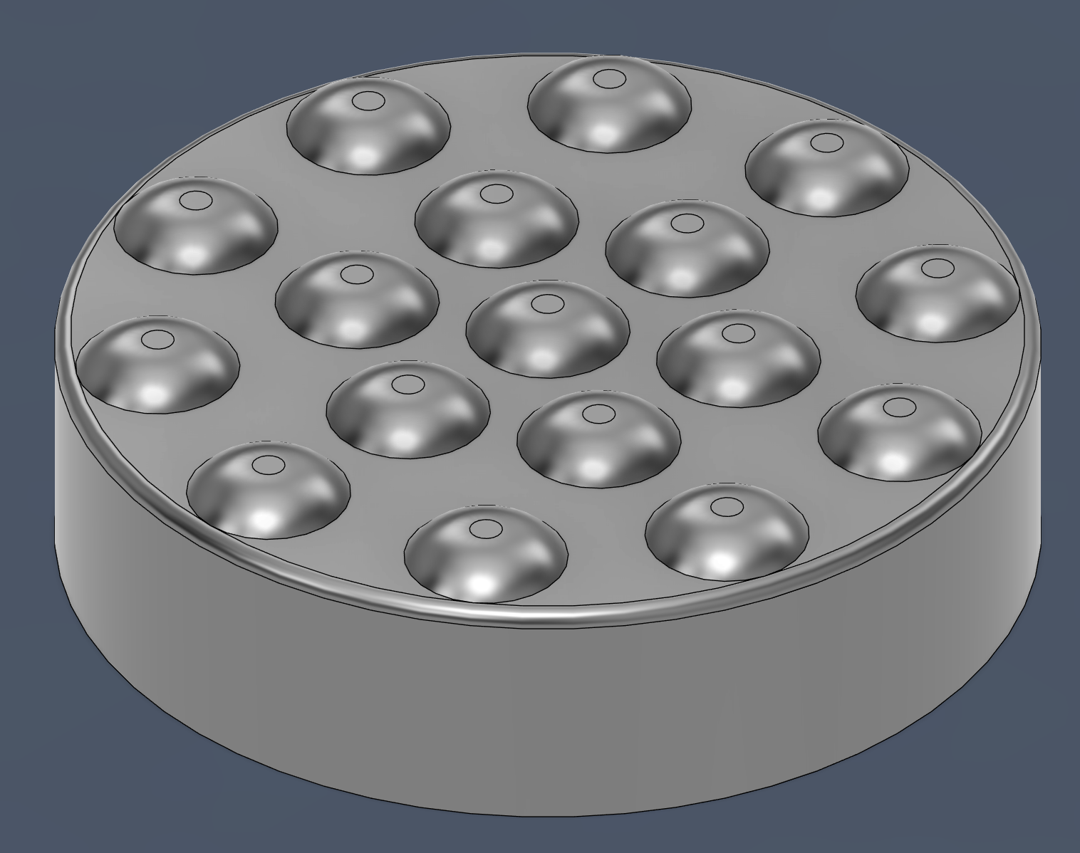

We recommend this option for someone who uses the same small set of custom tops regularly.

## Cleaning

The Chatterbox can be wiped with a damp cloth and any cleaner that does not harm plastic.

## Care

The Chatterbox is made of 3D printed plastic. Exposure to high heat may cause warping and/or negatively affect function. Extended exposure to sunlight will also weaken the plastic on the device.

The Chatterbox contains electronics and is not waterproof. If the device becomes wet, make sure it is off and do not use it until it has completely dried. It may help to open the enclosure to speed up drying and ensure it has completely dried.

## Disposal

PLA filament may be industrially compostable in your area. Check with your waste management company if PLA can be composted or must be thrown in the garbage.

Disassemble the Chatterbox and separate out the recyclable and compostable components, and those that must be thrown out. Electronics and batteries should be disposed of following your local waste management guidelines.